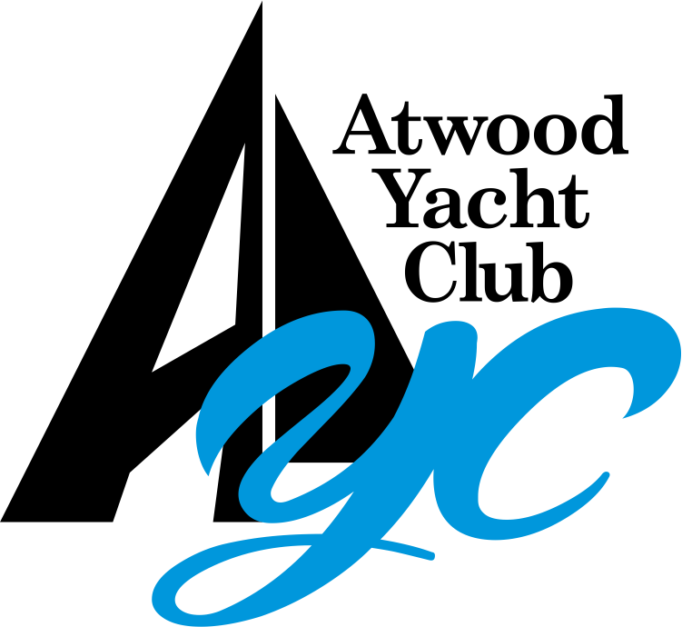

Annual Meeting Agenda

October 09, 2022

Call to order
- Roll Call & Confirmation of Quorum
- Approval of 2021 Annual Meeting Minutes

Elections:
- Motion to Approve the Nominees for Board of Trustees and Officers
- Floor Nominations
- Election of Officers, Trustees, and Ballot Issues

Annual Reports:
- Commodore’s Report – Aaron Ley
- House Committee Report – Sean Hinkle
- Brewery - Sean Hinkle / Mike Pickens
- Finance/Safety Committee – Amy Weegar / Ron Dzeidzicki
- Treasurer – Rick Andrews
- Membership – John Richard
- Building, Grounds, and Pool – Mike Burkhart
- Docks – Jeff Yohe
- Social – Tod Ebetino, Michael Norman
- Bylaws & Governance - Tom Turner
- Sailing Fleet – Neil Beavers
- Junior Sailing – Tyler & Stacy Rippel
- Auxiliary – Cathy Palmer
- Communications - Kristi Pickens

New Business

Old Business

Election Results:
- Officers, Trustees, and Ballot Issues
- Motion to Destroy the Ballots

Adjourn

