2022 Slate of Nominees for Officers & Trustees

Sean Hinkle - Candidate for Commodore
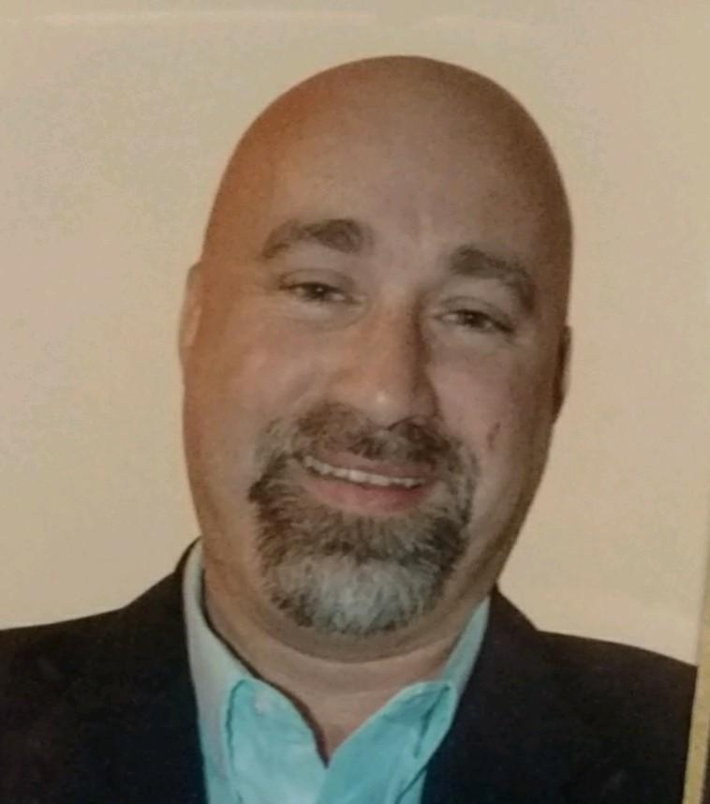
I was born and raised and currently live in the Atwood lake area. My wife Cheryl and I have been together for 30 years and I have been employed with the same company for 27 years as a field technician. When I took my first position of building and grounds trustee, it was my goal to support the club and the wonderful people that enjoy it as well as support the members of the board that have become my friends over the years of my membership at the club. I have served as Rear Commodore, and chaired the social committee. It has been a really amazing position to be in because I absolutely love meeting people and making new friends. I pride myself on being very approachable. I believe I have received a lot of respect from my fellow board members and that is why I would ask for your vote for vice commodore. I would consider it a great honor to serve in this position.

Amy Weegar – Candidate for Vice Commodore
I moved to the lake and joined AYC seven years ago, and haven’t looked back! I live across the lake in Arrowhead with my dog, Callie. Prior to becoming Rear Commodore last year, I served as Secretary for 3 years, and enjoy the challenge of keeping the club’s organized and on task. I am a certified PMP Professional, with a background of 15 years of Project Management. I also have earned the CSM-I designation for Agile Project Development. I specialize in Agile Project Delivery and Change Management for special events, advertising, and Information Technology. I am currently the Manager for Website Development and Consumer Data Privacy at the J.M Smucker Company. I plan to use these skills to modernize some of our club offerings, using technology to improve our services & events.

John Richard – Candidate for Rear Commodore
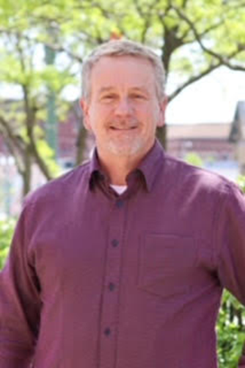
John Richard became president of the Stark Education Partnership (SEP) in 2021, leading the non-profit organization through a strategic planning process. Before joining SEP, he served as Deputy State Superintendent at the Ohio Department of Education (ODE) in Columbus for five years, previously serving as a senior executive director and associate superintendent for the ODE. He was the Associate Executive Director for OASSA overseeing professional development of principals across Ohio and served as Superintendent of Perry Local Schools in Stark County from 2005 until 2013. He also has been a part-time instructor at the University of Akron in the principal licensure program.
The education leader is enthusiastic about increasing capacity of quality leadership to prepare students for their next step after high school and is an experienced speaker and facilitator, effectively working with diverse groups. He often facilitates leadership teams or groups through one- or two-day retreats. He has a bachelor’s degree from the University of Mount Union, a master’s degree from Cleveland State University, and earned his doctorate at the University of Akron.
He has served on various boards, currently serving on the Strengthening Stark Governance Committee and University of Mount Union Alumni Association and M Club (athletics). He is involved at his local church and participates in a weekly multi-cultural Bible study. He enjoys running, hiking, boating, and traveling. He and his wife Kim have five children and an ever-increasing number of grandchildren!

Aaron Ley – Candidate for Past Commodore
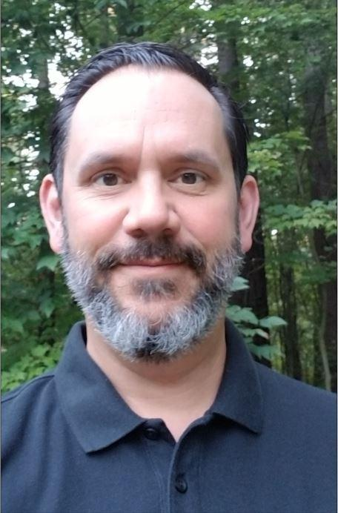
I am a lifelong resident of the Dover-New Philadelphia area and moved to the lake in 2015. I recently built a new home in the Glens and I am happy to say Atwood Lake is now my permanent residence. I enjoy all aspects of lake life, especially time with family and friends on the water. I have a son Jared 25 and daughter Devan 23. I graduated from Bowling Green State University before returning to the area to work with my parents in their business. I am the owner of Robert’s Medical Uniforms which sells nursing uniforms and embroidered apparel to businesses, hospitals, colleges, and nursing facilities. We have been a long-time provider of the AYC clothing line and staff uniform shirts. I have been a member of AYC myself for 6 years, serving as the Commodore, Chair of the Social Committee in 2019, on the House Committee and as the Chair of the Finance committee in 2020. I truly enjoy the friendships I have made at the club and I would be honored to serve as your Past Commodore. I look forward to helping grow the club so that others can enjoy the place that I and so many others have come to know as home.

Rick Andrews - Candidate for Treasurer
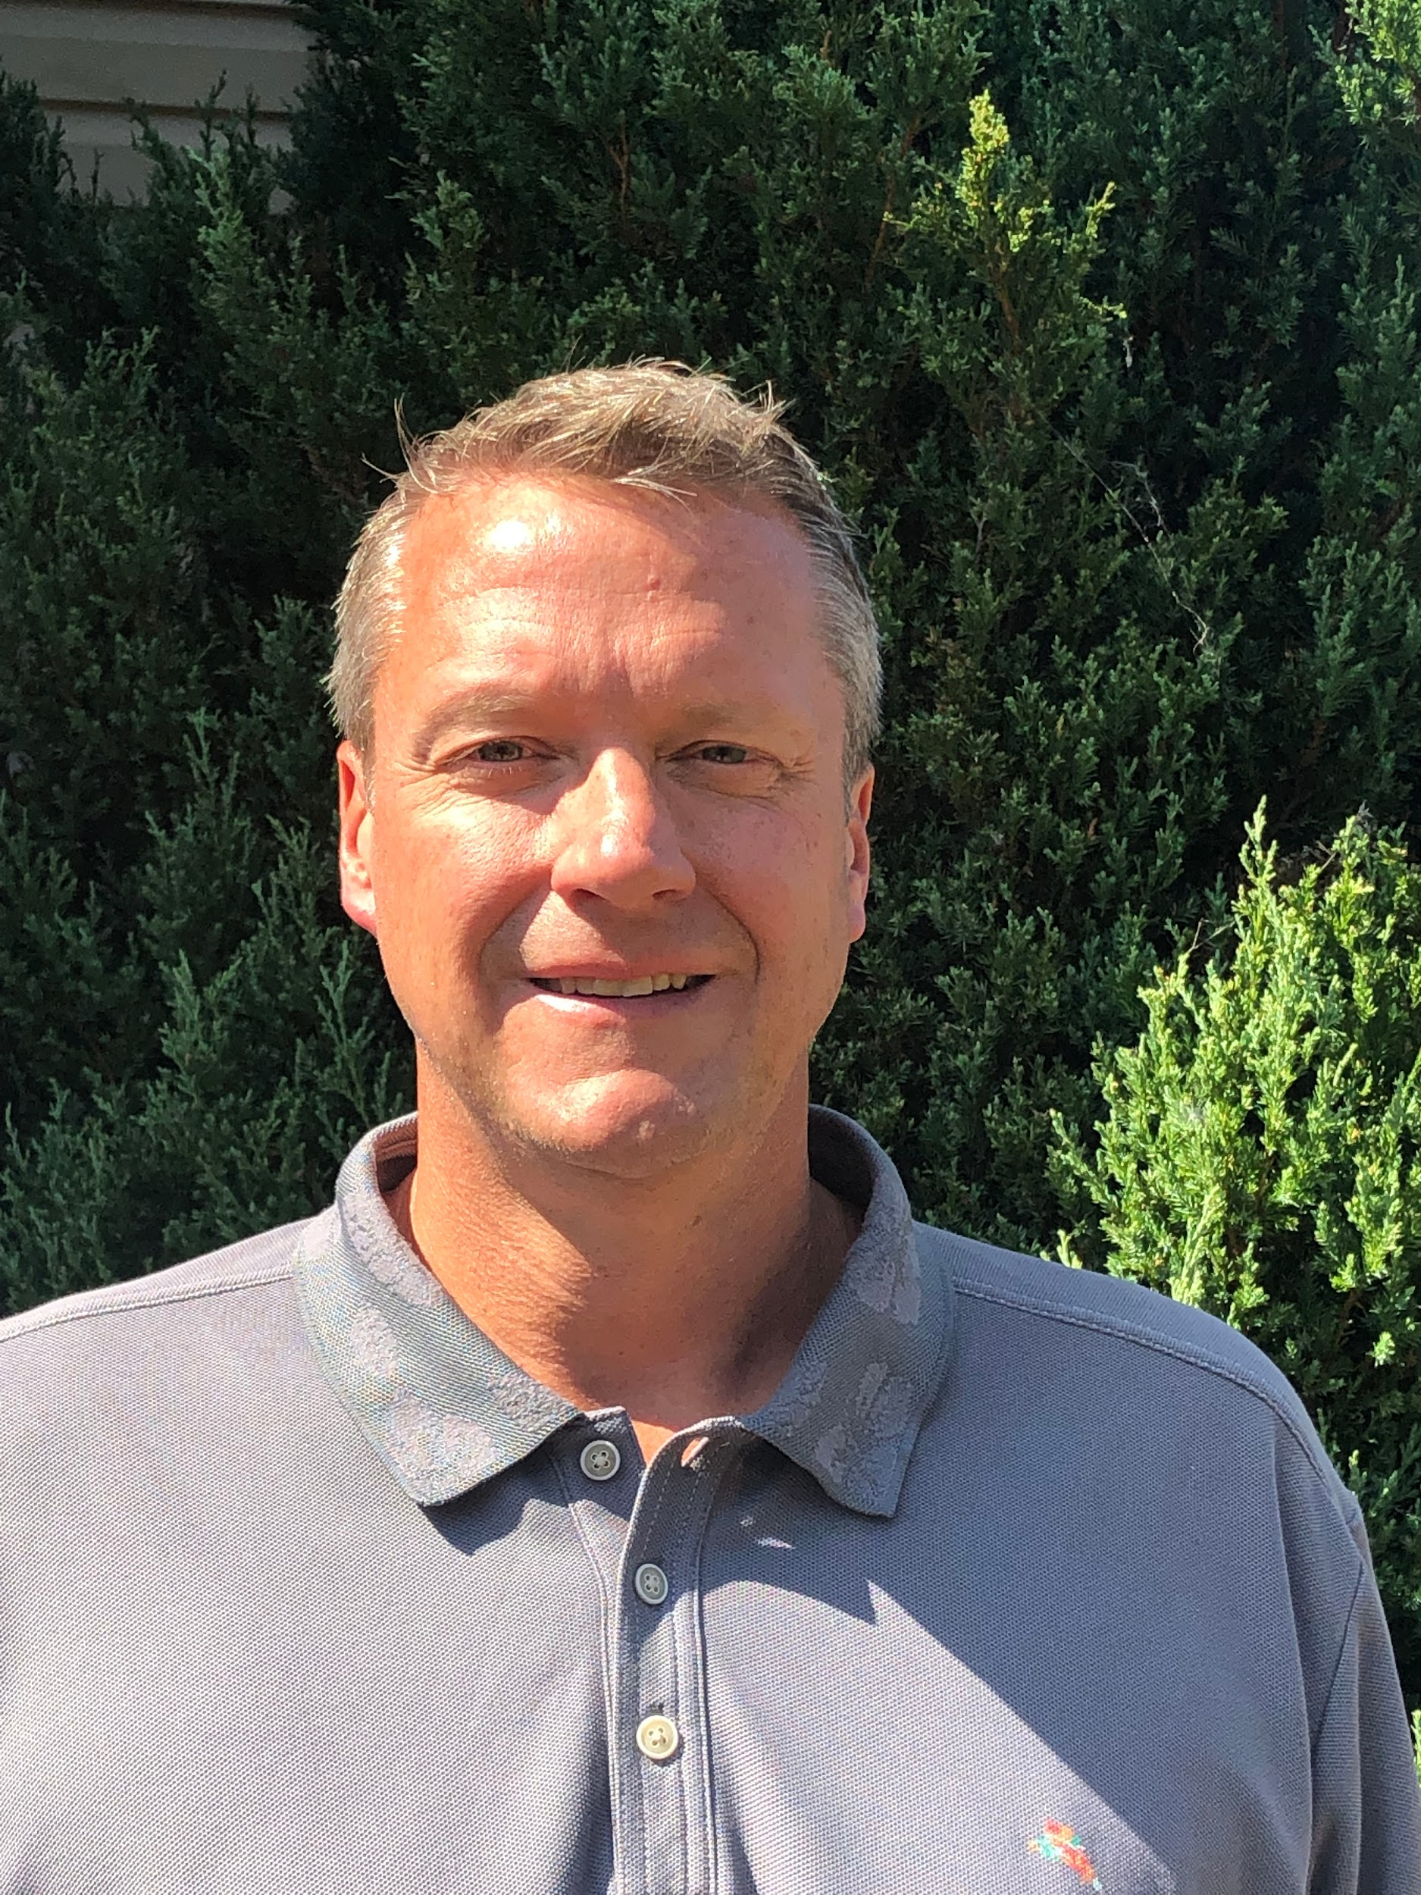
My wife Erica, and two sons Jake & Luke, have been AYC members for the past five years. We have enjoyed meeting people at the Club and spending time on the lake. I am a Certified Public Accountant and Partner at Troyer & Associates, Inc. I am currently serving on several boards and committees in the community, including finance committee at Broadway United Methodist Church, board member Dover Phila Federal Credit Union, board member United Way of Tuscarawas County, and member of Kiwanis Club of Dover-New Philadelphia. I hope to support the Club going forward by drawing on my past experiences of working with small businesses.

Ron Dziedzicki - Candidate for Secretary
I reside in Medina Township, Medina, OH with my wife of 41 years, Mary Ann. We have three sons, Matthew (Jessica), Christopher and David (Sarah). We have two lovely daughters in law and four grandchildren, Brendan, Abby, Elijah and Anna. I hold a Bachelor in Science of Nursing from Ursuline College, Master in Business Administration from John Carroll University and a Masters of Strategic Studies. I am a graduate of the US Air Force War College and the US Army War College (MSS). After a 32-yr career with the United States Army Reserve, I retired as the Commanding General of the 3rd Medical Command located at Fort Gillem, GA. I retired as the Chief Operating Officer of University Hospitals Medical Center/University Hospitals Physician Services at the end of 2019. I have served on multiple not for profit boards over the last 20 years, American Red Cross, Medical Center Company, Boy’s and Girl’s Club of NE Ohio, etc… as a means to contribute to the community.
My wife and I have been coming to the Atwood Region for 40 years, and her family has been vacationing in the region since the 1960’s. My wife and I purchased a second home in the Cove Cottage area the fall prior to my retirement from the US Army. My hobbies include physical fitness, reading, boating, fishing, and spending time with my family. Joining the Atwood Yacht Club has been a fun and enjoyable experience, as we continue to meet new members and building new friendships. After serving the nation for 32 years, and as the current AYC Secretary this past year, look forward to continuing to support and serve the Club and its membership

Rick Beyers - Candidate for Trustee

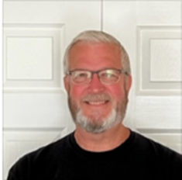
Current Status:

Administrative and finance professional recently retired January 2022. I believe that by joining the AYC Board that I will be able to assist the Commodores and Officers to continue their successful achievement of the Club’s mission related to the encouragement of the sport of boating and yachting, education of the science of seamanship and yachting, building friendships and stewardship of the Club’s resources for all members due to my operational and financial experience. I am a two-time member of the Club – once from approximately 2005 through 2009 and I rejoined mid-year 2020.

My 40-year professional career consisted of employment at three different entities.I worked in the healthcare industry for 34 years. 28 years at Cleveland Clinic and 6 years in Catholic health care. At the Cleveland clinic I held 4 different positions: Senior Internal Auditor, Division Administrator and Finance Director for the Cole Eye Institute, Clinical Finance Director for all clinical institutes and Institute Administrator for the Orthopaedic & Rheumatologic Institute. At retirement, I was the non-physician leader in the Orthopaedic & Rheumatologic Institute responsible for daily operations, financial operations and P&L management for a $600M budget, strategic direction and all human resources.

When I worked in Catholic healthcare, I held the Corporate Director of Internal Audit position for a multi-hospital system located in Northeast Ohio with a direct reporting to the Finance Committee of the board of trustees.

Prior to my healthcare career, I worked in public accounting providing professional services to middle market closely held businesses.
Education:
- Masters Degree in Business Administration Cleveland State University, Cleveland, OH 1993
- Bachelor of Science Degree with major in Accounting University of Akron, Akron, OH 1981
Professional Certification:
- Certified Public Accountant State of Ohio 1983
Prior Board Experience:
- Humility of Mary Housing: Treasurer 1993 through 1995
- National Orthopaedic and Spine Alliance: Cleveland Clinic representative on the Finance Committee 2015 through 2017
Personal:
I am married to Joni and we have three grown adult children ranging in age from 31 to 25

Michael Burkhart - Candidate for Trustee
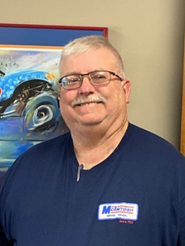
I am a 1984 graduate of Canton South high school. I have lived in East Sparta my entire life. Shortly after graduation I began working for Pike Township, and within a short period of time was promoted to Superintendent of Roads. After several years I started work in the oil and gas business and have been in the oil business for over 30 years. I was the superintendent for Enervest Oil and Gas responsible for over 12,000 oil wells across the state of Ohio until 2021 when I went to work for McIntosh Oil as the operations manager with sales responsibilities. During my career I have created relationships with a wide variety of construction trades within the community.
One of the challenges I see is maintaining an aging facility so that members and guests continue to have a pleasing experience when visiting the club. It is also important to maintain a beautiful facility so that we can continue to attract private events such as weddings, reunions and business meetings whose income will help support the financial well-being of the club. During my first term I was able to leverage my experience in management and the trades to add value to our Club by managing a number of building and grounds projects that impacted the pool, building structures, HVAC equipment and landscaping. Of note we were able to make improvements to the pool resulting in uninterrupted operations and zero violations during the recent health department inspections. If re-elected I will work hard to continue helping Atwood Yacht Club improve membership experience, add value to membership and improve and maintain our facilities. I would appreciate your vote.

John Elsasser- Candidate for Trustee
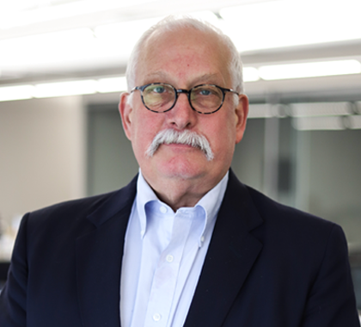
Originally from Canton, I have lived in Zoar since 1991 with my wife, Cindy. A graduate of Canton Lincoln High School, the College of William and Mary, and the Harvard Business School, I worked for The Timken Company in Canton, Bucyrus, Ohio, Sao Paulo, Brazil and Colmar, France in information technology, manufacturing management, project management and general company management before retiring as Senior Vice President in 2009. I also own the Canal Tavern of Zoar and serve on several non-profit and private company boards. My hobbies include Zoar (where I am president of the Zoar Community Association), history, woodworking, genealogy, and travel. We have two adult children, Erica, who lives in Los Angeles and Kurt, who lives in Columbus. We have been members of the yacht club since 1995 and, while not boat owners, we enjoy being club members and believe the club is an important asset for Atwood and the Tuscarawas/Carroll area.

Steve Pollock - Candidate for Trustee

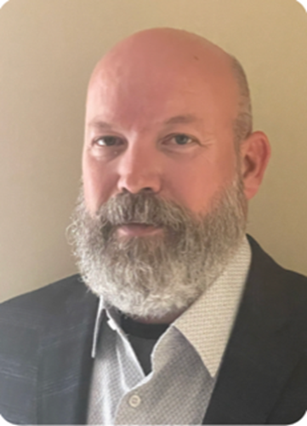
Steve Pollock has been a resident of the Atwood Lake region since 2002 and is passionate about all things Atwood Lake, most notably pontooning on a lazy afternoon weekend with Heather and friends.

By day, Steve is a project manager for a commercial office furniture dealer, Ohio Desk. His deep understanding of the commercial construction and renovation process has made him invaluable in the role for over ten years. In his tenure at Ohio Desk, Steve has run significant and successful projects at notable northeast Ohio businesses such as Diebold, Swagelok, Westfield Insurance and MetroHealth. Prior to joining Ohio Desk, Steve was operations manager for Morris Office Environments in Canton, Ohio. Steve holds a BS in Anthropology from The Ohio State University.

Steve currently resides in Magnolia, Ohio with his son Gus, a rising senior at Sandy Valley. When not on the lake, Steve can be found in the garage wrenching on one of his cars, working on a project boat or on the racetrack.

Stacy Rippel - Candidate for Trustee
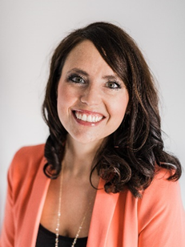
My family and I reside in Bolivar, but enjoy spending most weekends on Flying Colors, our sailboat docked here at AYC. Tyler and I have been married for 15 years and have two boys, Micah – 12 and Harper – 8. I received a Bachelor of Science in Nursing degree from Malone College and a Master of Science in Nursing Leadership and Management from Walden University. I also maintain a specialty certification in Gerontological Nursing. I have had the pleasure of serving in numerous leadership positions and on several quality councils throughout the Aultman Health Foundation over the past 16 years. Currently, I am the Executive Director of the Coronary Care Unit at the Aultman Deuble Heart and Vascular Hospital. Tyler and I are members of the New Philadelphia First United Methodist Church, and I have also served as a board member for its Creative Fish Preschool. From engagement in the club, my family has developed a passion for sailing. In addition to Flying Colors, we have race boats in our growing MC Scow Fleet and look forward to Sunday and Wednesday races. I am an active member of AYC Sailing Fleet, and Tyler and I became the Chairs of the AYC Junior Sailing Camp Program this past year. It has been a pleasure and honor to lead the youth program and to serve as an AYC trustee for the past two years. Being a part of the growth and witnessing the engagement of the boaters throughout the club has been a tremendous gift, and I look forward to continuing that trend in the future.

Tom Turner - Candidate for Trustee
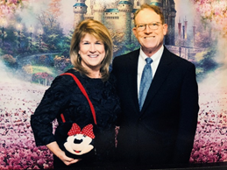
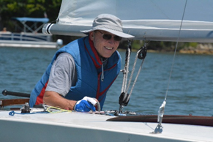
Tom is running for re-election for another term on the board. The past two years, he has led the By-laws committee, actively served on the membership committee, and also as a volunteer consultant for future capital projects planning at the club. He and his wife Sandy joined the Atwood Yacht Club in 1998. They raised their twin boys, Tim and Jeff, at the AYC spending summer weekends on Twin Wave- their sailboat. When the boys were young, the Turners were active at the club planning the annual Atwood kid’s carnival, helping with their junior sailing, and we continue racing with the Sailing Fleets.
Tom’s professional career has been in association management, philanthropy, and healthcare administration. For the past almost 18 years, Tom continues as vice president at Cleveland Clinic Mercy Hospital and in 2011 became the founding President of the Mercy Development Foundation. Turner has worn many hats from new business development, physician practice management, to creating a new philanthropic hospital foundation. In the area of government relations, he is a registered Ohio healthcare lobbyist for the Cleveland Clinic. and also serves both Mercy and Union Hospitals service areas in government relations work. Prior to Mercy, he worked at Akron Children’s Hospital as vice president of business development and marketing.
Tom is a graduate of The Ohio State University, along with degrees from Pepperdine University (MBA) and doctorate from Walden University. For over two decades, he has served as a part-time adjunct professor teaching subjects in the areas of marketing, healthcare strategy, and operations management. When not boating at Atwood, Turner participates as a trumpet player in TBDBITL- OSU Marching Band Alumni, and is a Eucharistic Minister for the Episcopal Diocese of Ohio. He serves on multiple community boards, government committees, and the Austin-Bailey Health & Wellness Foundation.

Jeff Yohe - Candidate for Trustee
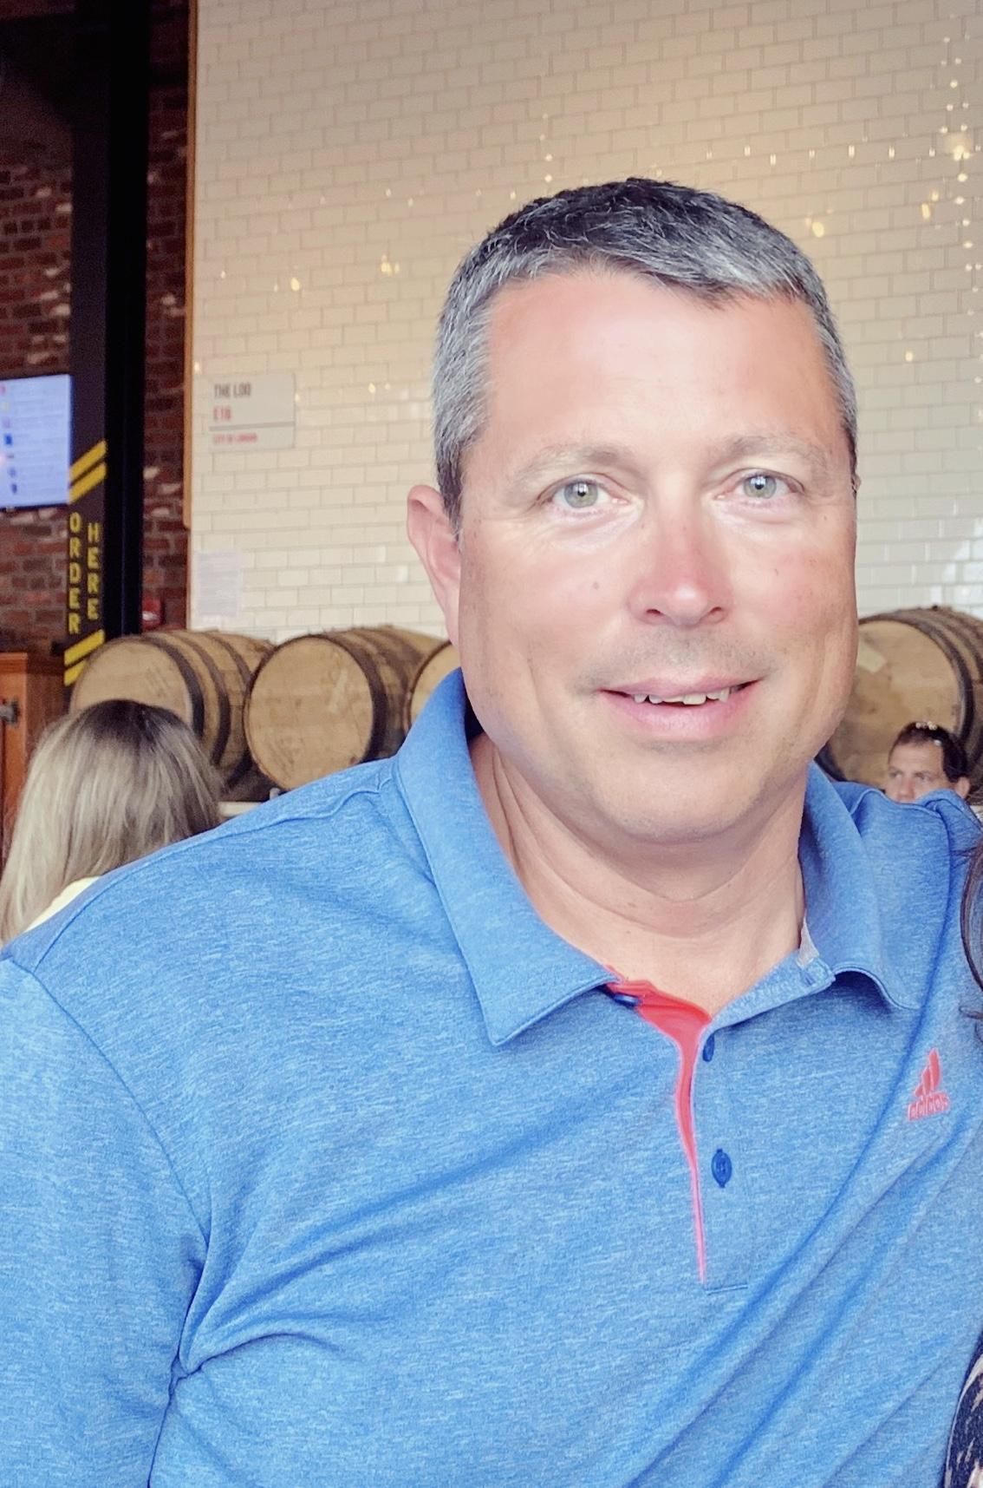
I reside in Jackson Township, Stark County with my wife, Jenn and son, Craig. My family has had the cottage at North Shore for the past 37 years. I grew up enjoying Atwood Lake and am glad to see my son do the same.
I received my civil engineering degree from Ohio Northern University and work for the Muskingum Watershed Conservancy District as the Deputy Chief - Facilities. I also currently serve as the President of the Atwood Regional Water and Sewer District Board. In my spare time, I like to fish, golf and boat. My wife and I enjoy spending time at the Club and have made many good friends since we joined and look forward to making many more.

