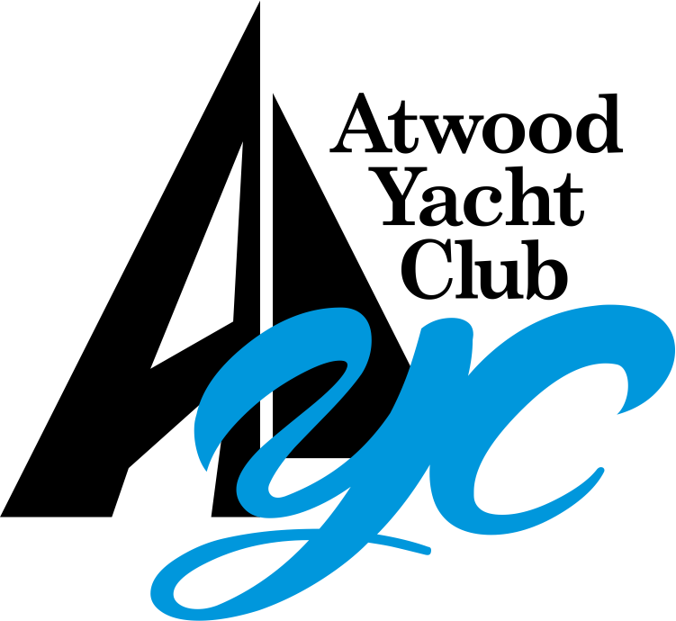
Annual Meeting Minutes – October 17, 2021

Call to Order & Roll Call
Atwood Yacht Club meeting was called to order by CommodoreJon Poulson. Due to the COVID-19 Pandemic, Roll Call is not taken this year to reduce the duration of time spent in the meeting. Member participation was noted upon entry to the Ballroom, or the Virtual Meeting.

Quorum requirements were met by members present, attending via video conference, and proxies received via Virtual Vote or Mail-in Ballot.

Approve Last Year’s Meeting Minutes
A motion was made by John Elsasser to approve the 2020 annual meeting minutes. It was seconded by Rick Enslen. Motion passed.

Approval of Nominations / Floor Nominations
Tom Turner made a motion to approve the slate of nominations and it was seconded by Brad Rippel. Nominations closed.

There were no nominations from the floor. Bev Shelley made a motion to close floor nominations and it was seconded by Tom Lallone. Nominations closed.

Election of Officers, Trustees, and Ballot Issues

Commodore’s Report – Jon Poulson – See Attached Report.
- 2021 has been another great year. Thank you for everyone coming today.
- We thrived even under the circumstances of Covid-19.
- Thank you to the chairs of the committees, and to the board members.
- We set out with Strategic Priorities for the year, and set a roadmap of goals to accomplish. If you review the report, you will see the major milestones that we’ve accomplished.
- As of today we have not yet drawn on our line of credit. We are breaking the cycle of using the line of credit as part of overall operations.
- Every dock we own is in the water - this is a major accomplishment
- We now have updated the Brewery, and encourage members to try our new beers.
- We’ve capped membership at 375, and have a waiting list.
- 2022 Budget is complete already as we prepare for next year.

House Committee Report –Aaron Ley – See attached report.
- It’s been an interesting year from the house perspective.
- Our GM moved on in the middle of the year, putting many of the responsibilities back on the House Committee.
  - We are working on the General Manager Search
  - We are doing a hired search, using a recruiter to help get us a manager.
- Thank you Sean and Jon Elsasser for serving on the committee.
- We were able to have more events this year, compared with 2020. The staff does a great job helping us put these on.
- Working on the infrastructure of the kitchen to ensure things move more quickly and efficiently
- Chef Brian has done an amazing job!
- Staffing has been very difficult, as with most other industries. We are faced with struggles with staffing. We have some ideas on how we will work through that using our 2022 budget.
- “The year of the Coolers” - we’ve had several coolers go out.

Brewery Report - Mike Pickens - See Attached Report
- The Brewery Committee was established as a Sub-Committee of House.
- Curt Adams retired this year as Brewmaster after 20 years. Thank you Curt for your service! If you see Curt, please say Thank You.
- Sean Hinkle and Josh Hunker have taken over the Brewery Responsibilities
- We replaced our aging beer lines, and added an additional 3 lines to increase our available taps to 6.
- We swapped Brewing Systems with Hoodletown, reducing from 10 barrels to 5 Barrels. This allows us to brew more often, giving a variety of beers. We will also be adding a storage cooler on the east end of the building. We have also purchased 20 additional kegs.
- Purchased 13 oz glasses so we can serve beers with a higher alcohol content.
- We’ve brewed Cope’s Kolsch, Main Sail Scottish Ale, Yachtoberfest, and up next is In Irons Tropical Stout - which should be on tap in a week or two.

Finance/Safety Committee –Sean Hinkle – See attached report.
- Thank you to the Finance Committee - Aaron Ley, Ron Dziedzicki, Rick Andrews, Rick Enslen, Pam Engel.
- We reviewed Insurance for the club this year, resulting in a favorable revision in our payment structure.
- Inflation has been a challenge this year, from food costs to building materials. This will likely be reviewed with Insurance next year.
- Signed a 5-year contract for the in-and-out of our Docks. This is a very time intensive process, so we did a 5-year contract instead of an RFP each year.
- Established a process for collection of outstanding Dues.
- Safety Update:
  - We still have systems and processes implemented for COVID.
  - We continue to use the HEPA Filters around the restaurant that scrub bacteria and viruses out of the air.
  - Worked with House Committee to put OZONE Generators in our HVAC System to ensure it kills bacteria, mold, and COVID.

Treasurer – Ron Dziedzicki – See attached report.
- Balance Sheets included for Month End Close, and the P&L has been added.
- This is the forecast for the financials through the end of the year. (8-months actuals plus projections.)
- We are slightly behind last year due to some of the federal / state rebates we got during COVID.
- We anticipate tracking favorably through end of year.
- Total income is up due to our Capped Membership (375). This exceeded our goal of 353.
- Inflation has been challenging:
  - COGS are up - alcohol, food, construction parts
  - In spite of these unfavorable trends, we are able to manage to the budget.
- Merchant Fees are driving increased expenses on Credit Card Transactions, and we will be evaluating.
- Repairs Costs are up.
- Sous Chef has moved to a Salary Position.
- We had a big capital refresh project; front of the pool house was replaced. Upgraded houseboat electrical lines, painted the pool house, new steps down to the houseboat docks.
- Net income is favorable this year, and favorable to budget.
- We are going into Off-Season - so we will begin to see 4th quarter negative variances. But, we believe we will be favorable for end of year.
- Thank you to the previous Commodores (Ken Weegar, Rick Artino) for their strategic vision on getting out of using the line of credit for operations.
- Invoices for Dues are going out on November 2nd. If you have changed our email or address, please contact Ron so we can keep this updated.
- We have been doing audits to ensure our committees and programs are as efficient as possible, and we have gotten the correct payments.

Membership – Vicki Flickenger – See attached report
- 60 new members last year; 80 new members this year.
- We did work on by-laws to have more categories, including U30, and Lifetime Memberships.
- U30 brings back the Junior Membership of the club, which would help us get some younger members in. This would help with the sailing group.
- Lifetime membership helps us establish a capital improvement fund so we can make some major repairs and enhancements.
- We had a lot of local interest in our Docks, and we had a lot more people requesting use of Courtesy docks. We did add additional 5 fingers on the other side of the dock, and added the Sailboat / Houseboat Courtesy docks.
- We had a great improvement with the new playground equipment, helping us attract younger families to diversify membership.
- Winter Dining will not be back this Winter.

Building, Grounds, and Pool – Mike Burkhart– See attached report
- No violations for our Pool Inspections. We had to get new filters in the pool.
- We had donations to fix our basins with new gravel.
- We got the new AYC Sign installed out front, it looks great.
- Contract with our Landscaping Company is saving us money on maintenance.
- Thanks Jim Demuth for fixing the boat ramp, only charging us for materials. He also ground out the stumps to prepare for the new playground
- Thanks Rick Artino, Paul Rozler, Brian Daugherty for stepping in to help.
- Pietro’s donated 8 dining tables so we could expand our dining room.

Docks - Jon Poulson for Jeff Yohe
- We had unprecedented demand for our docks.
- Both Courtesy Docks are now in the water, and we did add new space specific for sail boats and houseboats.
- We implemented a new dock finger on the West
- We are launching a capital campaign where we are focusing on major repairs with all docks.
- If you are a current member who needs a dock for 2022, please let Jeff Yohe know ASAP. We only have 7 slips left, so we want to ensure you get that right away.
- We should push members to NOT swim off the docks - this is dangerous due to our electricity.

Social – Sean Hinkle – See attached report
- We had some great events. Inflation is also hitting our entertainment, so staying within budget has been tough.
- The committee did a fantastic Christmas in July - and it was a very profitable event. We anticipate doing this one again.
- The New Philadelphia Steel Drum Band came out this Summer, and we will likely do it again.
- Thank you for our members who sponsored a band this year, it’s made a difference in our budget.
- Oktoberfest was very well attended, same with Dueling Pianos.
- Thank you to the Social Committee - they did an incredible job.
- We are always looking to membership to see what kind of bands and events they’d like to have. Get ahold of Stacy and her committee with your ideas.
- Guest Bartender / Guest DJ nights are coming up - if you are interested, let us know!
- Question: Any discussion on bringing back Blues and Brews? Not yet. We’d like to see it come back, but it is a huge undertaking. We’d likely need to break it into committees because it’s such a large task. So we are evaluating if we can do this - we’d like to see this come back.

Sailing Fleet – Bernie Marucci – See attached report
- The Harvest Moon Regatta was an amazing success - we had 45 boats sailing this year.
- The MC Scow fleet has continued to grow - We are going in a great direction keeping this robust and very active.
- Thank you to everyone who participated as Race Committee.
Bylaws - Tom Turner
- The goal of By-Laws is to update and align our governance with the current operating environment.
- We annually ensure the Blue Book is kept current for the benefit of the board and membership.
- We worked with Membership to address how we handle demand, and keep interest high in AYC.
- These items are now in the ballot vote.

Junior Sailing – Gary Lenhart
- We were happy to bring back Junior Sailing after not being able to have it last year due to COVID.
- This year, we did not do the overnight camp, we stuck with a day camp.
- Junior Sailing is a great recruitment tool - we have many members join because of the program
- We’ve had over 150 volunteers over the years. We formed a committee that has grown in the last few years, adding younger people who will be leading the program in the future.
- 25 sunfish, 2 MC Scows, 2 Runabouts - this is a large fleet to coordinate stickers and state registrations and maintenance.
- We charge a low fee for camp, $175 for a week. Kids show up with no idea how to sail, and end the week rigging the boats and sailing.
- We should be proud as a group what this program means to the kids. We have kids who have made sailing a major part of their lives.
- We have elected Tyler and Stacy Rippel as the new chairs for Junior Sailing!
- Thank you Gary and Judy for your time.

Auxiliary – Stacy Lapish – See attached report
- The auxiliary is open to both men and women - we need your help for projects around the club.
- The auxiliary is the fundraising part of the club, and we do projects for the club and the community.
- We cleaned out the two closets near the kitchen, giving Becca space for her supplies.
- We had a flower sale and large yard sale in the spring.

Communications– Amy Weegar – See attached report
- We redesigned both our emails and website this year. These were massive projects.
- Thank you Cheryl Abel, and Brooke Stiles.

New Business
Mike Comella
- This is our 4th year, and we’ve really enjoyed the club.
- Thank you members, officers, employees, and volunteers for a job well done.
- We have recently gotten a sailboat, but are looking for a slip in the basin.
- Can we accommodate more sailboats, and how do we optimize adding more areas so we can get more sailboats in spaces that are deep enough to accommodate it.
- Mike makes a motion to have the Dock Committee provide recommendations on how to optimize our docking plan to accommodate our members' needs based on 4-foot shoal draft. Brad Rippel seconded. Motion Passed.

Old Business
No Old Business

Election Results: Officers, Trustees, and Ballot Issues
- Officers and Trustees presented on the ballot were elected.
  - Officers passed as listed on the ballot.
  - 2021 New Trustees:
    - Tod Ebetino
    - Brian Harr
    - Michael Norman
    - Mike Pickens
    - John Richard
- All Bylaws Changes Passed.
- Thank you to our Past Commodores for their support this year, and for advice.
- Thank you to our officers
Tom Simmelink motioned to Destroy the Ballots. Rick Enslen seconded. The ballots have been destroyed.
Commodore Jon Poulson has adjourned the meeting.

